**Bicker Village Hall Hiring Charges**

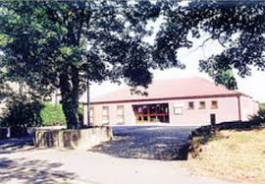

Bicker Village Hall, Cemetery Road, Bicker, PE20 3BT

|  |  |
| --- | --- |
| £15.00 | per hour**  (Main Hall and Gedney Room) |
| £10.00 | **per hour**  (Gedney Room) |
| £110.00 | **2pm until midnight**  (Main Hall and Gedney Room) |
| £150.00 | **a full day**  (Main Hall) |
| £100.00 | **A full day**  (Gedney Room) |
| £200.00 | **a full day**  (Main Hall **and** Gedney Room) |
| £50.00 | **Wakes** (a full day) |
| £7.00 | **Affiliated clubs and societies** (per hour) |
| £2.00 | **Compulsory charge per hour for heating (Oct 1st – 31st March)** |

**Main Hall can only be booked with Gedney Room

***** **50 % Deposit to secure the booking** *****

\*\*\*\*\***Total Hiring Charge – paid 1 month before date of hire** *****

|  |  |
| --- | --- |
| **Methods of Payment:** | 1. **Cheque** (payable to Bicker Village Hall) |
| 1. **BACs** (Bank: **Santander** Sort Code: **090154**  A/C : **68337983**) |
| 1. **Cash**  (in envelope with name and amount to the Booking Secretary) |